CSCI 4390 Senior Project Final Report
Title: Sports Chat+
Team Members:
- Ruben Aleman (ruben.aleman01@utrgv.edu)
- Joe Rivera (joe.rivera02@utrgv.edu)
- Abel Victorino (abel.victorino01@utrgv.edu)
- Emilio Aguirre (emilio.aguirre01@utrgv.edu)
Adviser: Dr. Zhixiang Chen

Project Description
Introduction
Sports Chat+ is a database-driven web platform designed to enhance the sports experience by integrating real-time chat, fantasy league features, and friendly wagering. The system will efficiently manage teams, players, games, user interactions, and transactions to create a seamless sports engagement experience.
Problem Summary:
While sports fans have access to a wide variety of platforms for watching games or checking scores, there is a lack of unified, interactive environments where users can engage with each other, track teams, and simulate friendly competition in real time. Most existing platforms focus on either static updates or real-money betting, leaving a gap for fans who want a secure, community-driven experience.
Motivation:
SportsChat+ was developed to address this gap by offering a comprehensive platform for sports discussion, virtual betting, and bracket simulation — all in one place. For this version, we utilized the NCAA March Madness tournament as the primary dataset to demonstrate functionality and interaction. This event allowed us to design realistic game structures, user roles, and dynamic user engagement features, laying the groundwork for future expansion to other sports.
Comparison of Existing Solutions:
- ESPN Tournament Challenge: Offers bracket prediction but lacks real-time chat or betting simulation.
- Reddit (r/CollegeBasketball): Active for discussion but lacks structure, moderation, and integration with game data.
- FanDuel / DraftKings: Focus on real-money betting and do not support role-based user interaction or gamified tracking.
SportsChat+ fills these gaps by providing an interactive, moderated platform for fans to discuss, predict, and engage — using virtual coins rather than real currency, and structured roles (Admin, Moderator, User) to ensure safety and clarity.
Proposed Solution Summary:
SportsChat+ is a web-based application featuring:
- A secure login and registration system with encrypted passwords and role-based access.
- A relational Azure SQL database supporting team data, player stats, game logs, and betting history.
- Real-time chat rooms linked to specific teams and games.
- A virtual betting system with coin balances and wager tracking.
- Scalable architecture that supports multiple sports beyond March Madness in future versions.

Functional Requirements
SportsChat+ provides users with an interactive platform to engage with sports events through real-time discussions, virtual betting, and bracket tracking. For this implementation, the NCAA March Madness tournament was used as a test case.
The core functional requirements include:
• User Registration & Authentication
Users can sign up with a username, email, and password. All passwords are securely hashed using bcrypt. Authentication enables role-based access to features.
• Role-Based Access
Three roles are supported: Admin, Moderator, and User.
– Admins manage users and system settings
– Moderators handle chat content
– Users can place bets, chat, and track games
• Team and Player Data Management
Team and player data for March Madness is stored and retrievable through SQL queries. Player stats are updated based on game results.
• Game and Bracket Tracking
Games are tracked by round, and winners are advanced using bracket logic. The Next_Game and Bracket_Seeding tables support this progression.
• Real-Time Chat Rooms
Users can enter chat rooms tied to a team, game, or general discussion. Messages are stored with timestamps and associated with both a user and chat room.
• Virtual Betting System
Users can place bets using virtual coins. Each bet is logged with wager amounts, involved users, and game reference. Bets can be updated based on game outcome.
• Transaction & Payment Logging
Although no real money is exchanged, all coin transactions are logged in Payments and PaymentTransactions tables for auditability.
• API Logs and Monitoring
System interactions and API activity are recorded in API_Logs for tracking external data and debugging integration.
Architecture Overview
The SportsChat+ platform is built using a modular, full-stack web application architecture with a focus on maintainability, security, and scalability.
Frontend:
• Developed with HTML, CSS, and JavaScript
• Uses EJS templates for rendering server-side dynamic pages
• Provides user-friendly interfaces for login, chat, betting, and bracket navigation
• Responsive layout supports desktop and mobile access
Backend:
• Built with Node.js and the Express.js framework
• Routes are defined for user actions including login, registration, betting, chat messaging, and API log interaction
• Uses bcrypt for password hashing and validation
• Implements middleware for authentication and error handling
Database:
• Hosted on Azure SQL Database
• Structured as a fully relational schema with 17 tables, normalized to reduce redundancy
• Enforces data integrity with foreign keys and constraints
• Includes indexes on frequently accessed fields like UserID, TeamID, and GameID to improve query performance
APIs and Integration:
• Integration layer fetches or simulates data for team matchups and brackets
• All API interactions are logged using the API_Logs table
• Additional routes allow dynamic interaction with team/player data
Deployment:
• The application is fully deployed using Azure Web Apps
• GitHub integration allows continuous deployment and version control
• Environment variables and connection strings are managed securely in Azure
Algorithms & Data Structures
The design of SportsChat+ balances relational database principles with application-level logic to ensure consistent, performant interactions across features like bracket updates, chat, and betting.
Normalization Strategy:
• All data is normalized to 3rd Normal Form (3NF) to avoid redundancy.
• Tables like Players, Teams, Games, and GameStats are linked by foreign keys to preserve data integrity and reduce duplication.
• User-related tables (Users, UserPermissions, Payments, Bets) are structured for modular interaction and future scalability.
Indexing and Performance Optimization:
• Indexes are applied to high-frequency query fields such as UserID, TeamID, GameID, and Email.
• Composite keys are avoided in favor of single-column integer primary keys for faster joins and simplified indexing.
• This indexing strategy improves query speed for leaderboard generation, login lookup, and chat retrieval.
Bracket Progression Logic:
• The Next_Game table maps the flow of games across rounds (e.g., winner of Game A feeds into Game B).
• A backend function checks the WinnerID of a completed game and automatically updates the Team1ID or Team2ID of the next linked game.
Virtual Betting Workflow:
• The Bets table supports tracking wagers between two users on a specific game.
• Logic ensures both users must confirm the wager. After a game is completed, a backend script determines the winner and adjusts coin balances.
• Coin changes are recorded in the PaymentTransactions table, supporting auditability and rollback if needed.
Chat Messaging Storage:
• Chat messages are written in real time to the ChatMessages table, linked to Users and ChatRooms.
• Messages are sorted by timestamp, and pagination is supported for performance.
Security Algorithms:
• User passwords are encrypted using bcrypt, which applies salted hashing to prevent plain-text password exposure.
• Role-based access enforcement is handled through the UserPermissions table joined with RoleLookup, restricting access to sensitive routes and operations.
Code Roadmap
The SportsChat+ web application is organized into modular components across backend and frontend directories, following best practices for scalability and clarity.
1. Backend – sportschat-backend/
Handles all server-side operations, API routing, and database connectivity.
- server.js: Initializes the Express server, sets up middleware, connects to the database, and defines routing logic.
- fetchNCAAGames.js: Custom script for retrieving NCAA game data (e.g., from an API or web scraping) to populate the database.
- test-server.js: Optional server testing entry point.
- .env: Stores environment variables such as DB connection strings and API keys (excluded from GitHub).
- package.json: Declares server dependencies (e.g., Express, CORS, dotenv).
2. Frontend – sportschat-frontend/src/
Built with React, this directory contains user interface components, services, and style files.
a. Pages – /src/pages/
These React components represent individual screens of the app.
- LoginPage.js, SignupPage.js, ForgotPasswordPage.js: User authentication screens.
- HomePage.js: Main hub for accessing features.
- DashboardPage.js: Displays team stats, standings, and possibly brackets.
- TeamsPage.js, StatsPage.js, SimplifiedDatabaseTestPage.js: Specialized views for NCAA team data and testing output.
- Button.js: Reusable UI component for buttons.
- Logo.png: Static image used in headers or auth pages.
b. Services – /src/services/
- api.js: Centralized module for frontend-backend communication using fetch or axios. Handles API calls like login, fetch teams, post messages, etc.
c. Styles –
- App.css, style.css, index.css: CSS files for component-level and global styling.
- logo.svg: Application logo used in headers or footers.
d. Other React Files –
- App.js: Root component defining main app structure and routing.
- App.test.js, setupTests.js, reportWebVitals.js: Boilerplate files for performance monitoring and Jest testing.
- index.js: Entry point for React rendering.
3. Templates – templates/
Store sample HTML, export files, or test page templates used during development.
Table Naming Conventions
To maintain consistency in database structure:
- Primary Keys (PK): The primary key of each table is the unique identifier, named as <TableName>ID.
Example: TeamID (PK), UserID (PK).
- Foreign Keys (FK): Foreign keys reference related tables, following the pattern <ReferencedTable>ID.
Example: TeamID (FK) in Players references Teams(TeamID).
- Standard Naming: Table names are plural (e.g., Teams, Users).
– Column names use camelCase or underscores for readability (e.g., FavoriteTeamID, date_played).
– Avoid reserved keywords or ambiguous abbreviations.
- Constraint Naming:
Constraints follow a standardized format for clarity:
– Primary Key: PK_<TableName>
– Foreign Key: FK_<ChildTable>_<ParentTable>
– Unique Constraint: UQ_<TableName>_<ColumnName>
– Check Constraint: CK_<TableName>_<ConditionDescription>
Example: FK_GameStats_Games, CK_Teams_SeedRange.

Data Retrieval Efficiency
To ensure optimal performance, the database will implement:
- Indexing: Frequently queried fields like UserID, TeamID, and GameID will be indexed to speed up search operations.
- Normalization: Data will be structured to minimize redundancy, ensuring efficient storage and retrieval.
- Optimized Queries: Joins and transactions will be designed to reduce query execution time, improving real-time data updates.

User Access Control
To manage security and access, user roles will be stored in the UserPermissions table:
- Admin: Full control over database management, user bans, and system settings.
- Moderator: Limited privileges, including chat moderation and managing user-generated content.
- User: Standard access, including participating in discussions, viewing games, and placing virtual bets.
User roles will restrict actions like modifying game data, making payments, or changing permissions to authorized personnel only.
Security Considerations
To protect user data and transactions, the system will implement:
- Password Hashing: User passwords will be stored using bcrypt for encryption and security.
- Transaction Security: Virtual coin transactions and game betting records will be verified and encrypted.
- API Access Control: Rate limiting and authentication measures will prevent unauthorized API requests and spam.
- Role-Based Access Control (RBAC): Ensures only authorized users perform critical operations.
Database Design Overview
Table Name | Purpose
1. Teams | Stores NCAA team information, including names, coaches, and bracket seeding.
2. RoleLookup | Stores definitions of user roles (e.g., Admin, Moderator, User).
3. Users | Stores user credentials, profile info, and favorite team references.
4. UserPermissions | Links users to their assigned roles using the RoleLookup table.
5. Players | Tracks player details, including position, height, and team assignment.
6. Games | Stores game schedules, teams involved, scores, and round information.
7. GameStats | Logs player performance metrics for individual games.
8. ChatRooms | Defines chat spaces associated with teams, games, or general topics.
9. ChatMessages | Stores user-generated messages within chat rooms.
10. API_Teams | Stores external team data mapped to local team records.
11. API_Games | Stores external game data linked to local game entries.
12. API_Logs | Logs activity related to API transactions and integrations.
13. Payments | Records real-money coin purchases made by users.
14. PaymentTransactions | Tracks detailed coin transactions tied to specific payments.
15. Bets | Stores wagers placed between users on game outcomes.
16. Bracket_Seeding | Assigns official tournament seed numbers to teams.
17. Next_Game | Links current games to their next scheduled matchups in the bracket.

Core Tables
1. Teams Table
Stores NCAA team details participating in March Madness.
CREATE TABLE Teams (
TeamID INT PRIMARY KEY,
TeamName VARCHAR(100) NOT NULL UNIQUE,
CoachName VARCHAR(100),
Conference VARCHAR(100),
Wins INT DEFAULT 0,
Losses INT DEFAULT 0,
Seed INT CHECK (Seed BETWEEN 1 AND 16)
);
2. RoleLookup Table
CREATE TABLE RoleLookup (
RoleID INT PRIMARY KEY,
RoleName VARCHAR(50) NOT NULL UNIQUE
);
3. Users Table
Tracks scheduled and completed games.
CREATE TABLE Users (
UserID INT PRIMARY KEY,
Username VARCHAR(50) UNIQUE NOT NULL,
Email VARCHAR(100) UNIQUE NOT NULL,
PasswordHash VARCHAR(255) NOT NULL,
FavoriteTeamID INT,
FOREIGN KEY (FavoriteTeamID) REFERENCES Teams(TeamID)
);
4. UserPermissions Table
CREATE TABLE UserPermissions (
UserID INT PRIMARY KEY,
RoleID INT NOT NULL,
FOREIGN KEY (UserID) REFERENCES Users(UserID),
FOREIGN KEY (RoleID) REFERENCES RoleLookup(RoleID)
);
5. Players Table
CREATE TABLE Players (
PlayerID INT PRIMARY KEY,
TeamID INT,
PlayerName VARCHAR(100) NOT NULL,
Position VARCHAR(20),
HeightCM INT,
WeightKG INT,
JerseyNumber INT,
FOREIGN KEY (TeamID) REFERENCES Teams(TeamID)
);
6. Games Table
CREATE TABLE Games (
GameID INT PRIMARY KEY,
Round VARCHAR(50),
DatePlayed DATE,
Location VARCHAR(255),
Team1ID INT,
Team2ID INT,
WinnerID INT,
ScoreTeam1 INT,
ScoreTeam2 INT,
FOREIGN KEY (Team1ID) REFERENCES Teams(TeamID),
FOREIGN KEY (Team2ID) REFERENCES Teams(TeamID),
FOREIGN KEY (WinnerID) REFERENCES Teams(TeamID)
);
7. GameStats Table
CREATE TABLE GameStats (
StatID INT PRIMARY KEY,
GameID INT,
PlayerID INT,
Points INT DEFAULT 0,
Rebounds INT DEFAULT 0,
Assists INT DEFAULT 0,
Steals INT DEFAULT 0,
Blocks INT DEFAULT 0,
MinutesPlayed INT DEFAULT 0,
FOREIGN KEY (GameID) REFERENCES Games(GameID),
FOREIGN KEY (PlayerID) REFERENCES Players(PlayerID)
);
8. ChatRooms Table
CREATE TABLE ChatRooms (
RoomID INT PRIMARY KEY,
RoomName VARCHAR(255) NOT NULL UNIQUE,
RoomType VARCHAR(20),
TeamID INT,
GameID INT,
FOREIGN KEY (TeamID) REFERENCES Teams(TeamID),
FOREIGN KEY (GameID) REFERENCES Games(GameID)
);
9. ChatMessages Table
CREATE TABLE ChatMessages (
MessageID INT PRIMARY KEY,
RoomID INT,
UserID INT,
Message TEXT NOT NULL,
Timestamp DATETIME DEFAULT CURRENT_TIMESTAMP,
FOREIGN KEY (RoomID) REFERENCES ChatRooms(RoomID),
FOREIGN KEY (UserID) REFERENCES Users(UserID)
);
10. API_Teams Table
CREATE TABLE API_Teams (
API_TeamID INT PRIMARY KEY,
ExternalName VARCHAR(100),
MappedTeamID INT,
FOREIGN KEY (MappedTeamID) REFERENCES Teams(TeamID)
);
11. API_Games Table
CREATE TABLE API_Games (
API_GameID INT PRIMARY KEY,
GameID INT,
SourceName VARCHAR(100),
FOREIGN KEY (GameID) REFERENCES Games(GameID)
);
12. API_Logs Table
CREATE TABLE API_Logs (
LogID INT PRIMARY KEY,
Description TEXT,
Timestamp DATETIME DEFAULT CURRENT_TIMESTAMP
);
13. Payments Table
CREATE TABLE Payments (
PaymentID INT PRIMARY KEY,
UserID INT,
Amount INT NOT NULL,
PaymentDate DATETIME DEFAULT CURRENT_TIMESTAMP,
FOREIGN KEY (UserID) REFERENCES Users(UserID)
);
14. PaymentTransactions Table
CREATE TABLE PaymentTransactions (
TransactionID INT PRIMARY KEY,
PaymentID INT,
UserID INT,
CoinChange INT,
TransactionDate DATETIME DEFAULT CURRENT_TIMESTAMP,
FOREIGN KEY (PaymentID) REFERENCES Payments(PaymentID),
FOREIGN KEY (UserID) REFERENCES Users(UserID)
);
15. Bets Table
CREATE TABLE Bets (
BetID INT PRIMARY KEY,
GameID INT NOT NULL,
UserID INT NOT NULL,
User2ID INT NOT NULL,
WagerAmount INT NOT NULL,
BetStatus VARCHAR(20),
WinnerID INT,
FOREIGN KEY (GameID) REFERENCES Games(GameID),
FOREIGN KEY (UserID) REFERENCES Users(UserID),
FOREIGN KEY (User2ID) REFERENCES Users(UserID),
FOREIGN KEY (WinnerID) REFERENCES Users(UserID)
);
16. Bracket_Seeding Table
CREATE TABLE Bracket_Seeding (
SeedingID INT PRIMARY KEY,
TeamID INT,
SeedNumber INT,
FOREIGN KEY (TeamID) REFERENCES Teams(TeamID)
);
17. Next_Game Table
CREATE TABLE Next_Game (
NextGameID INT PRIMARY KEY,
GameID INT,
NextGameRefID INT,
FOREIGN KEY (GameID) REFERENCES Games(GameID),
FOREIGN KEY (NextGameRefID) REFERENCES Games(GameID)
);
Testing and Evaluation
Testing was conducted on both the frontend and backend of the SportsChat+ application to ensure system reliability, correct behavior, and secure data flow. Below are the structured approaches used for evaluation:
Frontend Testing
• Component Rendering
Each React page component (e.g., LoginPage.js, DashboardPage.js, TeamsPage.js) was tested to ensure proper rendering without runtime errors. Layout integrity was manually verified across different screen sizes.
• Form Validation
User inputs were validated in real-time on the SignupPage.js, LoginPage.js, and ForgotPasswordPage.js. Scenarios tested include empty fields, mismatched passwords, and invalid email formats.
• API Integration Testing
The api.js service file was used to connect frontend forms to backend endpoints. Functional GET and POST requests were tested using Axios to confirm correct data handling:
– Team data loading into TeamsPage.js
– Game statistics display in StatsPage.js
– Chat message submission and retrieval
Backend Testing
• Endpoint Testing
Using Postman and manual fetches from the frontend, all routes in server.js were tested. Routes covered include:
– POST /login, POST /signup
– GET /teams, GET /games, GET /stats
– POST /chat, POST /bet
• Database Integrity Checks
The fetchNCAAGames.js script was used to seed the database. Foreign key constraints were verified, and deletions from tables such as Teams and Users were confirmed to cascade properly to related records like Players and ChatMessages.
• Betting System Validation
The virtual coin balance (UserCoins) and bet resolution logic (Bets) were tested for both winning and losing users. Transactions correctly updated balances and recorded winners.
• Environment Variable Usage
The .env file was used to manage database credentials and security keys. Environment switching was validated for both local and Azure deployments.
Deployment Testing
• Azure Web App Validation
After pushing code to GitHub, the application was deployed using Azure Web Apps. Live deployment was tested for:
– Working routes
– Chat functionality
– Live updates to teams and games
– CORS handling between frontend and backend
Bug Tracking and Fixes
• Layout bugs and minor rendering issues were resolved in files like DashboardPage.js and StatsPage.js.
• Incorrect API error handling was fixed in LoginPage.js and SignupPage.js.
• Coin validation bugs during bet placement were corrected in backend logic.

ER Diagram
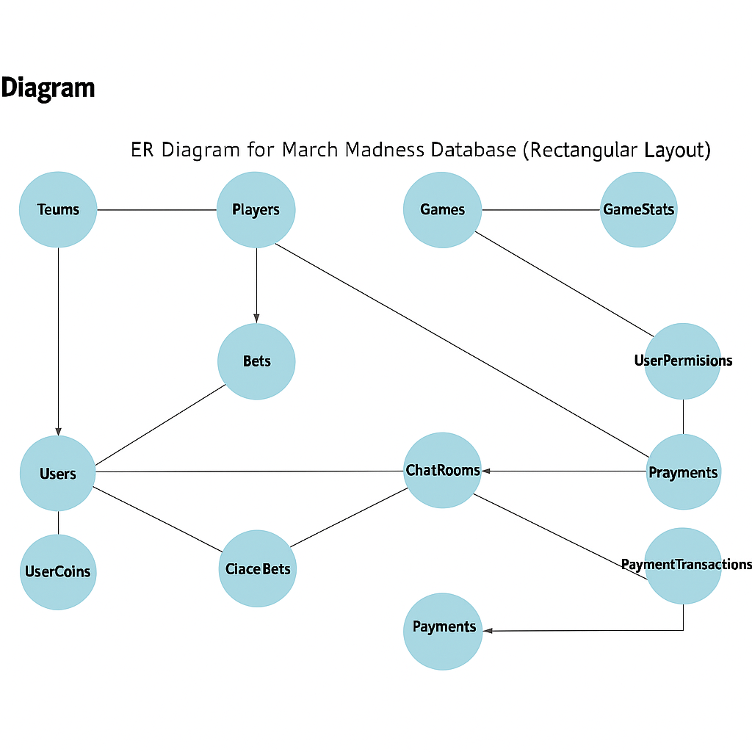

Table Relationship Diagram
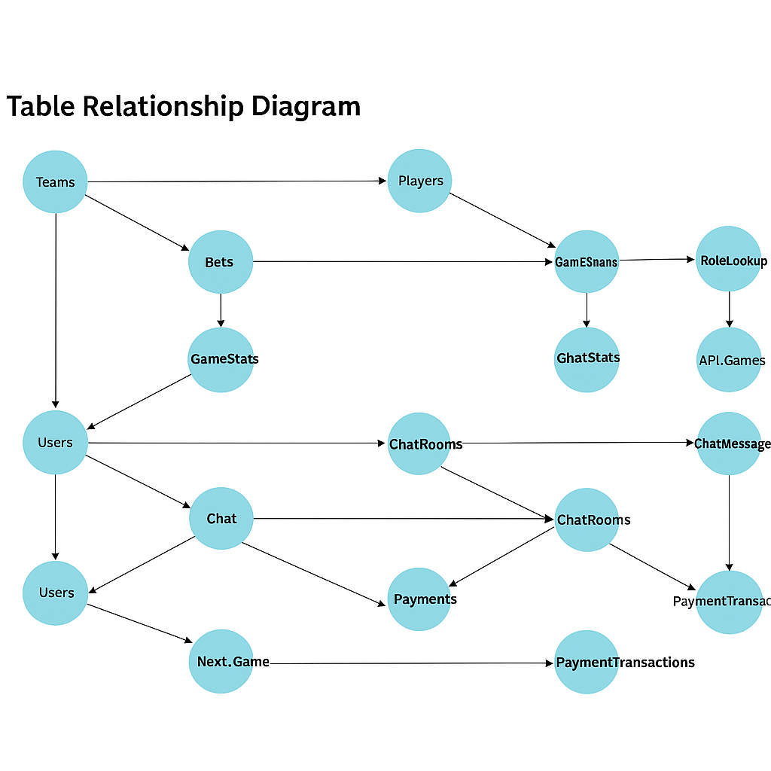

User Access Diagram
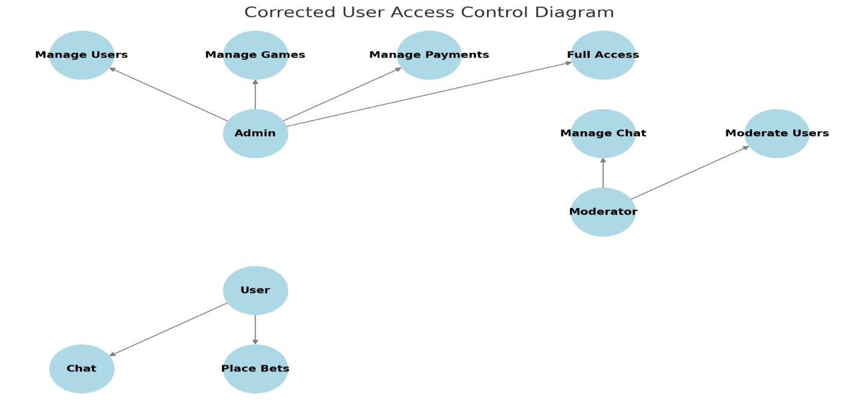

DATA Flow Diagram
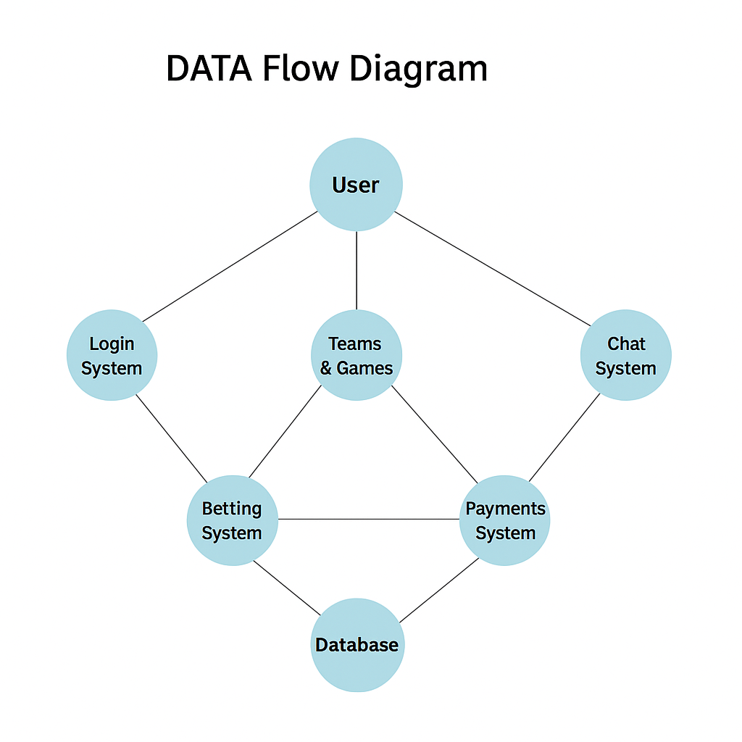

Table Name | Purpose
Teams | Stores NCAA teams
Players | Tracks team rosters
Games | Manages game schedule and results
Users | Stores user information
GameStats | Tracks player performance
Chat | Supports real-time messaging
UserPermissions | Controls user access levels

SportsChat+ Control Flow Table
Login Procedures
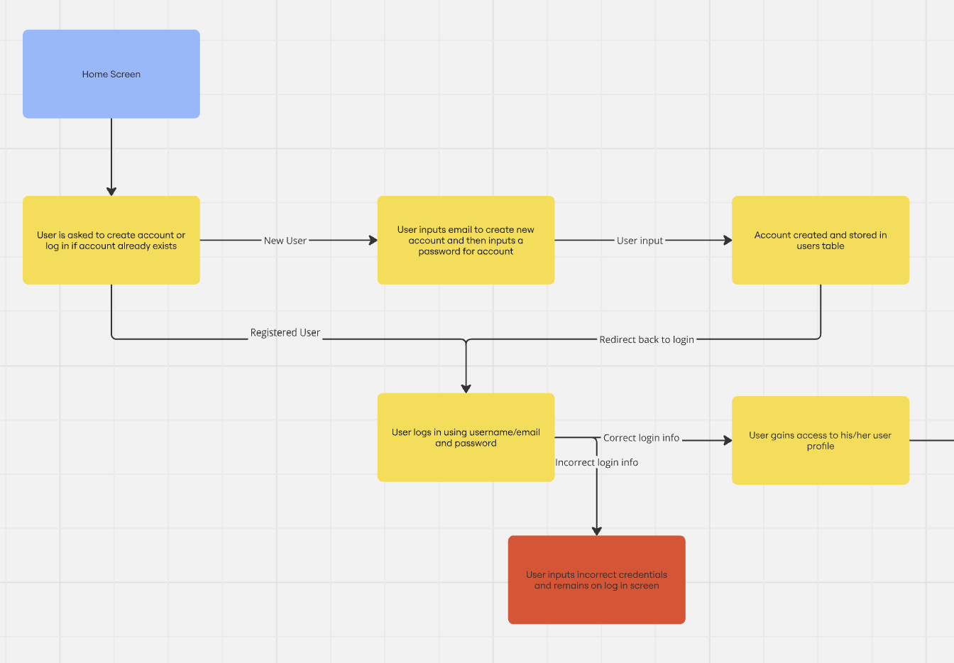
Website Flow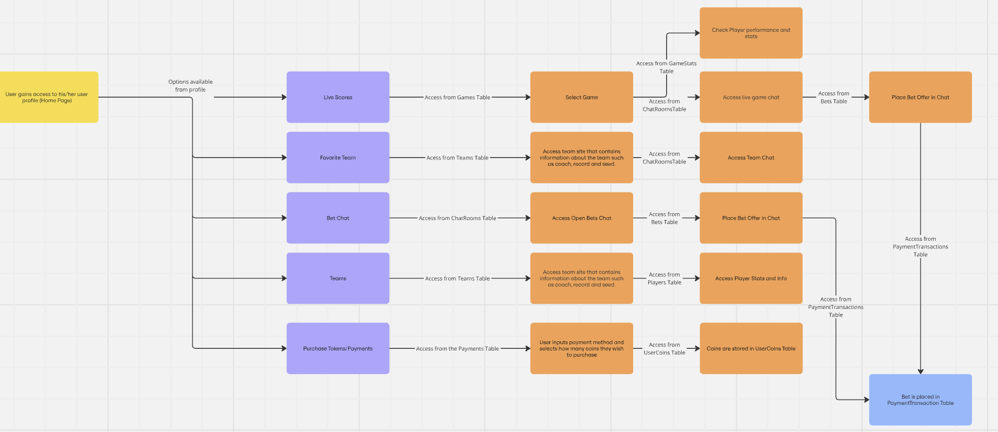

Overview
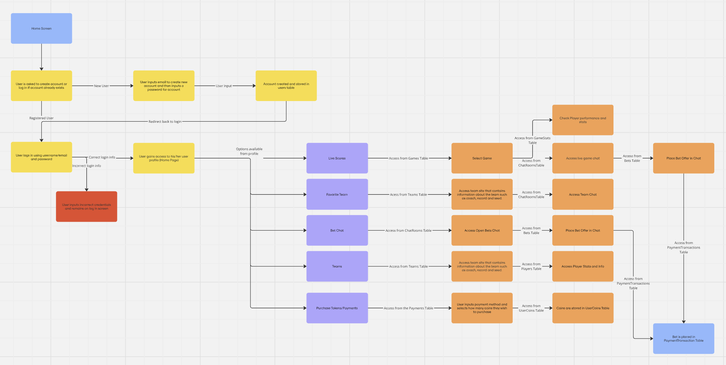

Interface Mockups
The following Figma mockups were designed during the planning phase to visualize the user experience.
- Login Screen: Allows users to sign in securely using their credentials.
- Dashboard / Bracket View: Displays upcoming games, teams, and tournament progression. Interactive features include bracket selection, virtual bets, and chat windows.
This follows the exact same flow design as the provided flow chart to give a visual representation of what we are intending our site to look like. This design symbolizes our minimum working product, we have intentions to add more features and expand our site as the semester progresses.

SportsChat+ Prototype
Login Procedures
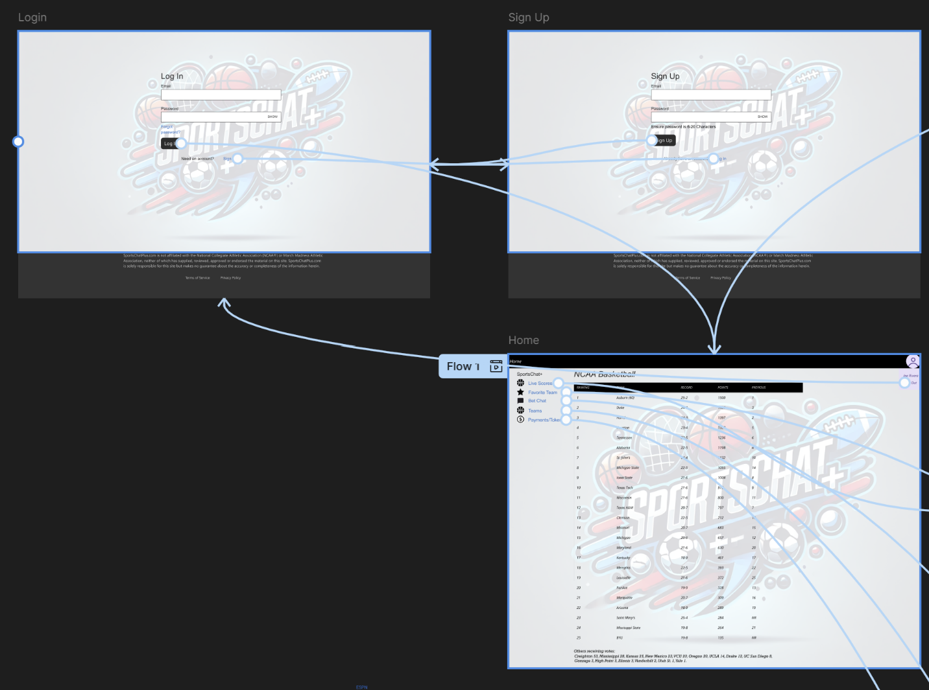
Website Flow
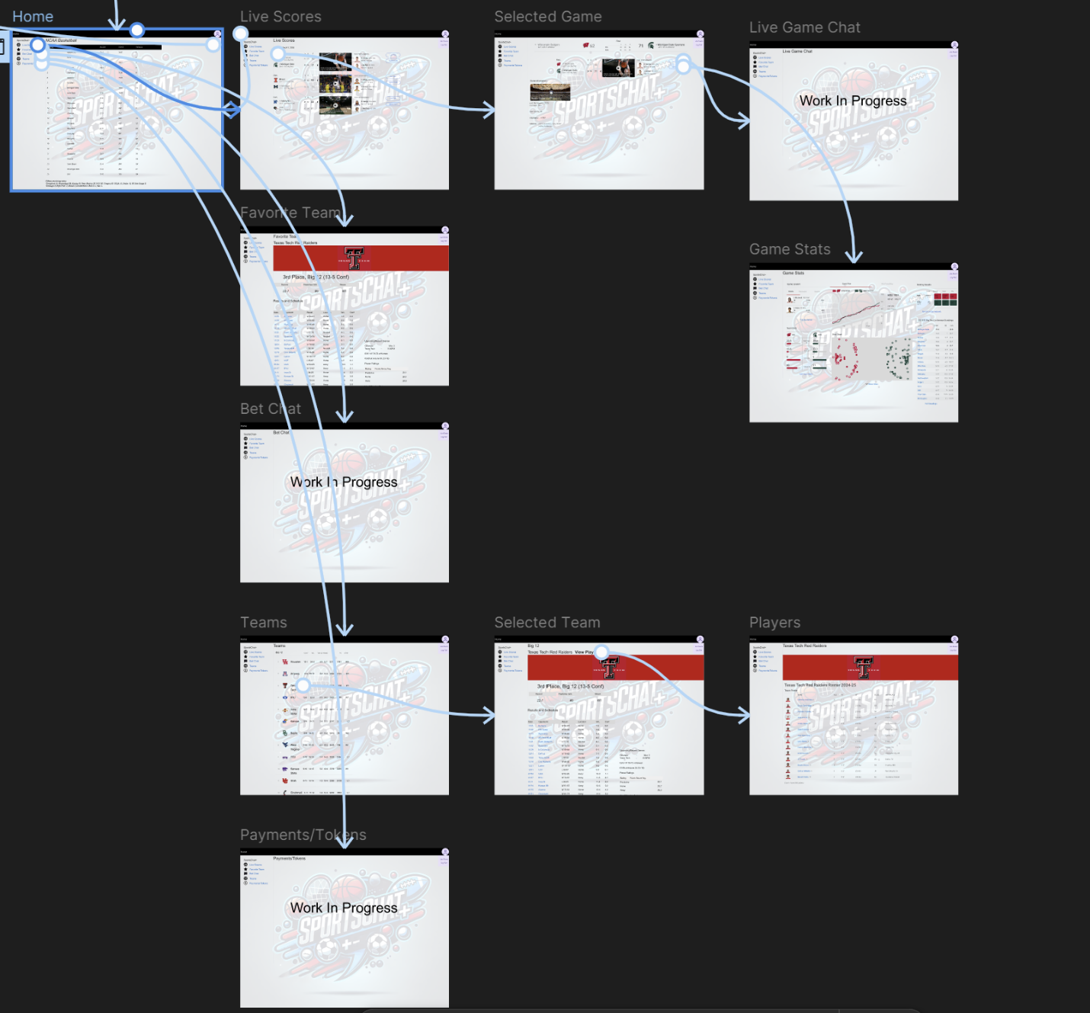
Overview
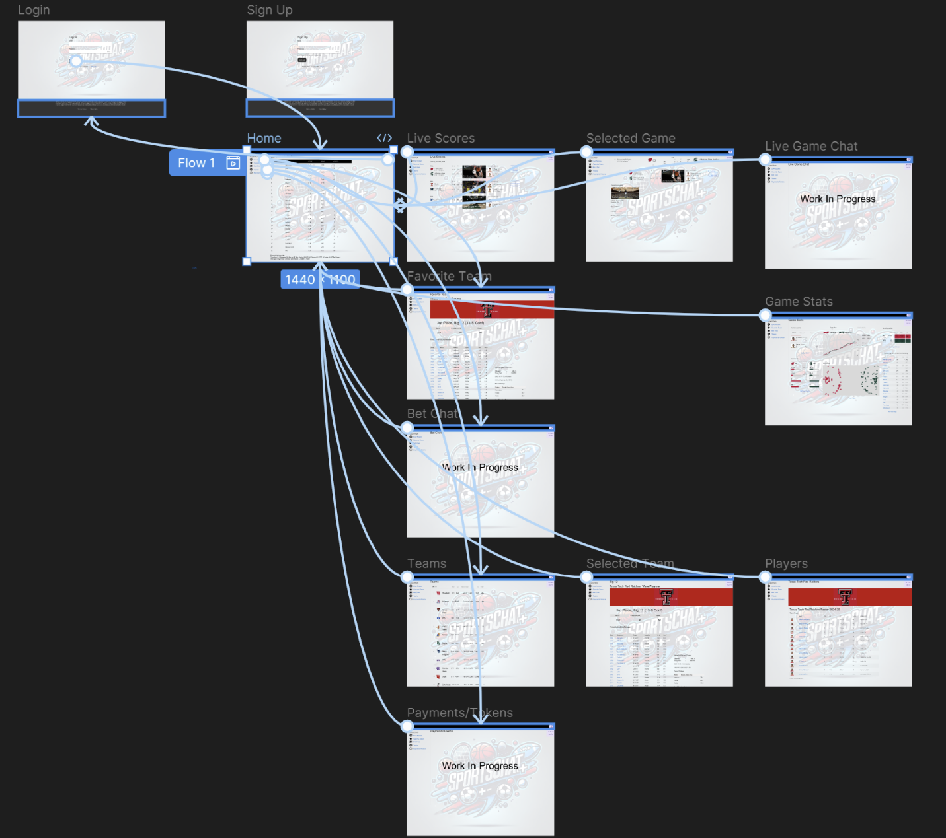
The link for the prototype:
https://www.figma.com/design/VL292phxTjEam8au1gGGr6/SportsChat%2B?node-id=16-2344&t=yBMXGsD8UrhRSgRp-1
Project Management
The development of SportsChat+ followed an iterative and collaborative workflow, focused on practical deliverables and consistent progress. Although it was built as a solo project, industry-standard tools and practices were used to simulate team development.
• Version Control:
All project files were managed using Git and hosted on GitHub. Feature-specific branches were used (e.g., dashboard-ui, api-auth, sql-schema) to ensure modular progress and reduce merge conflicts. Clear commit messages tracked each stage of development.
• Task Tracking (Jira):
A Jira board was used to manage tasks and milestones throughout the project. Tasks were categorized by phase (e.g., frontend, backend, database) and labeled as "To Do," "In Progress," or "Done."
Epics included:
– Authentication System
– Chat Features
– Azure Deployment
– Testing & Documentation
• Milestone-Based Development:
The project followed a milestone-driven timeline:
- Week 1: Project setup, database schema finalized, user auth created
- Week 2: Game tracking, betting logic, and database interactions
- Week 3: Chat system and dashboard UI built
- Week 4: Testing, deployment to Azure Web Apps, final report
• Challenges & Resolutions:
- Azure SQL connection configuration was a key obstacle early on
- CORS issues were resolved by configuring middleware in Express
- Bracket logic required refactoring to properly reference Next_Game links
- Frontend alignment and mobile responsiveness took additional iteration
Lessons Learned & Evaluation
Developing SportsChat+ offered hands-on experience with full-stack development, cloud deployment, and database design under realistic project constraints. The process not only reinforced technical skills but also highlighted the importance of design planning, modular structure, and testing discipline.
• Key Takeaways:
– Working with Azure SQL taught the importance of managing remote database permissions and secure connections.
– Designing a normalized relational schema helped improve understanding of data integrity, foreign keys, and JOIN queries.
– Using React with Express improved experience in routing, component reuse, and frontend-backend separation.
– Jira task management helped track progress and simulate a collaborative workflow with accountability.
– Implementing role-based access control solidified backend logic security.
• What Worked Well:
– Deployment to Azure Web Apps was successful, enabling real-time testing of production behavior.
– The chat systems were implemented cleanly with minimal bugs.
– SQL indexing and normalization made data retrieval fast and reliable.
• What Could Be Improved:
– A stronger initial design for state management in React (e.g., use of useContext or Redux) would have improved scalability.
– Unit and integration tests could have been automated to ensure reliability after updates.
– More detailed error handling and user feedback would improve UX, especially for failed bets or login errors.
– The last push and merge for the planned Betting Page broke code and did not allow our Web App to load as it was previous. More rigorous testing before merging should have been implemented.
• Future Enhancements:
– Implement OAuth (e.g., Google login) for easier authentication
– Add user profile customization and avatars
– Integrate a live API for NCAA scores and automate bracket updates
– Expand chat with WebSockets for real-time interaction

